Министерство образования Республики Беларусь

Учреждение образования

БЕЛОРУССКИЙ ГОСУДАРСТВЕННЫЙ УНИВЕРСИТЕТ

ИНФОРМАТИКИ И РАДИОЭЛЕКТРОНИКИ

Факультет компьютерных систем и сетей

Кафедра программного обеспечения информационных технологий

Дисциплина: Разработка программного обеспечения для мобильных платформ

ОТЧЕТ

По лабораторной работе №5

Тема работы: «Игра»

Выполнил:

студент: гр. 051006 Шуляк А.В.

Проверил: Коловайтис Н. А.

Минск 2023

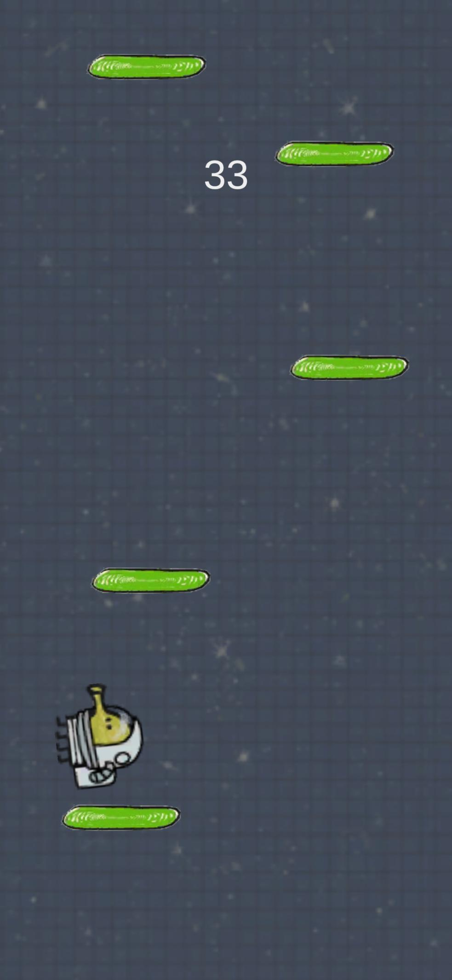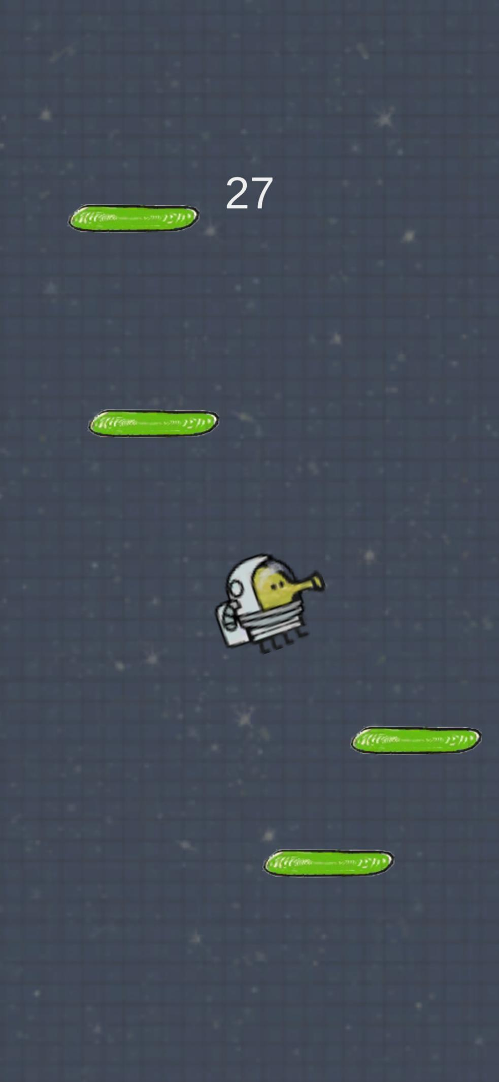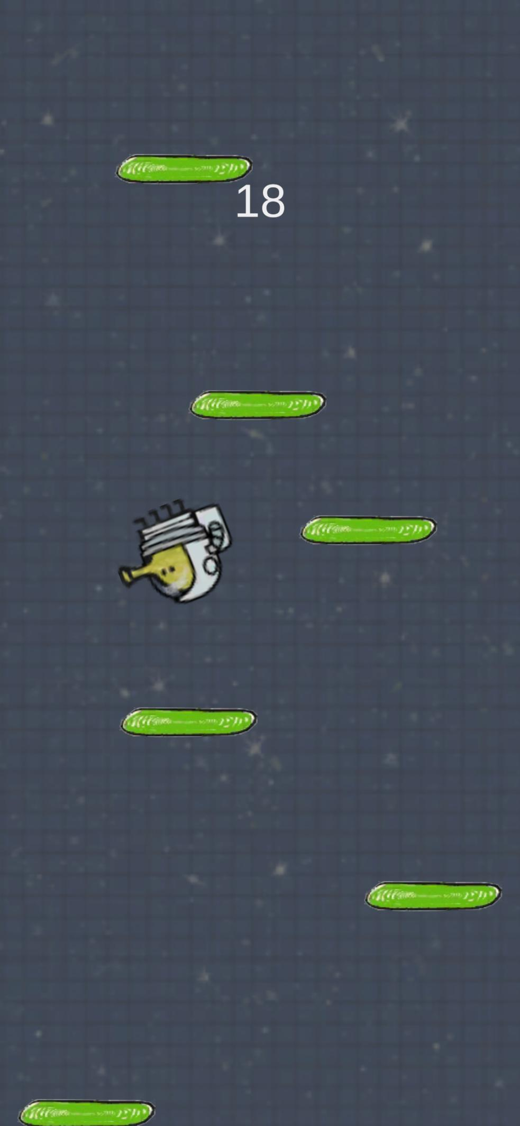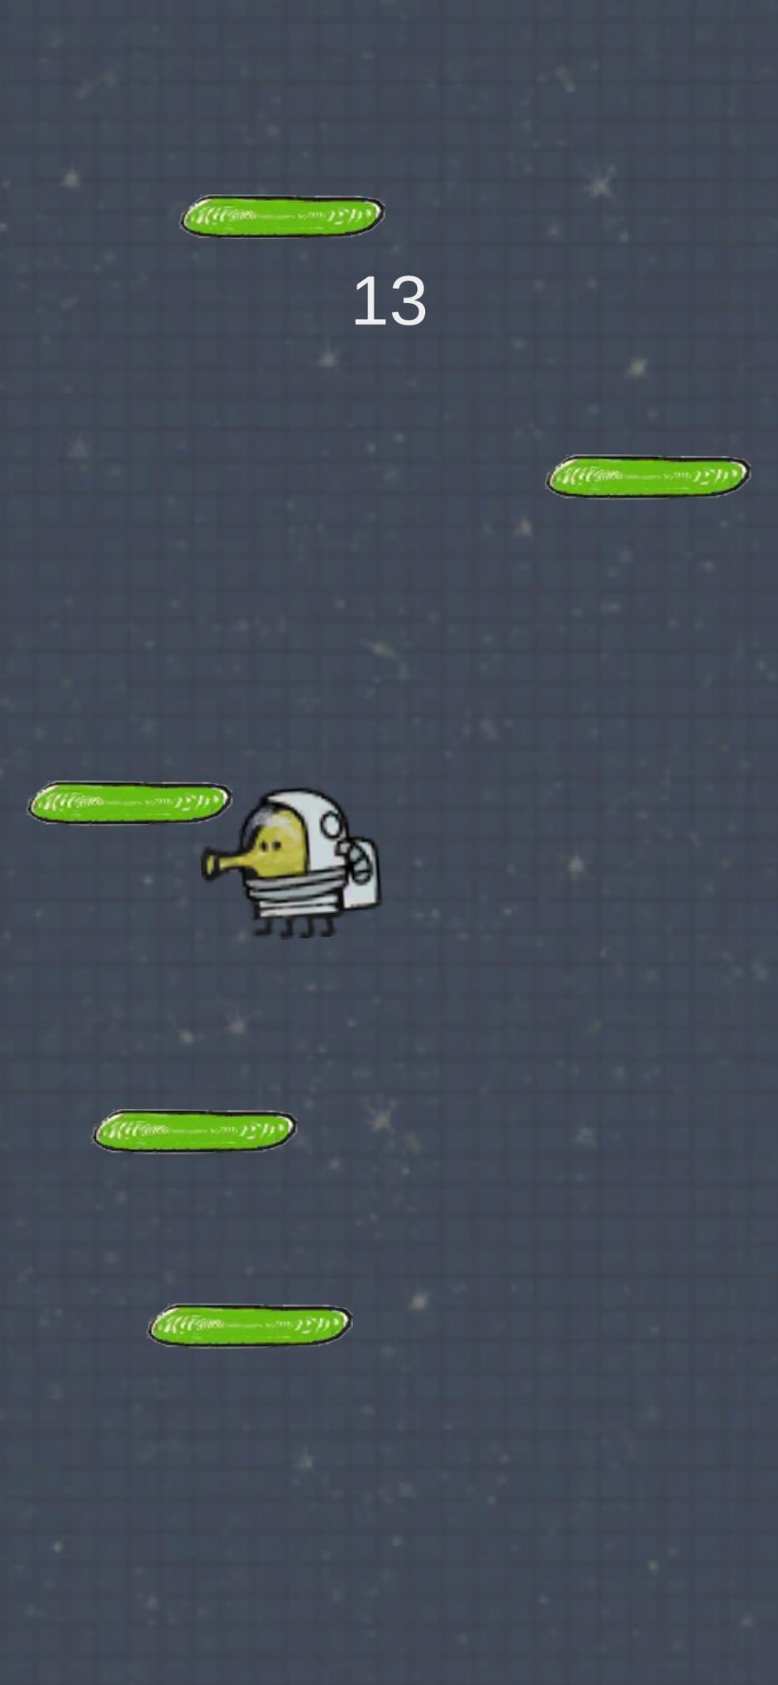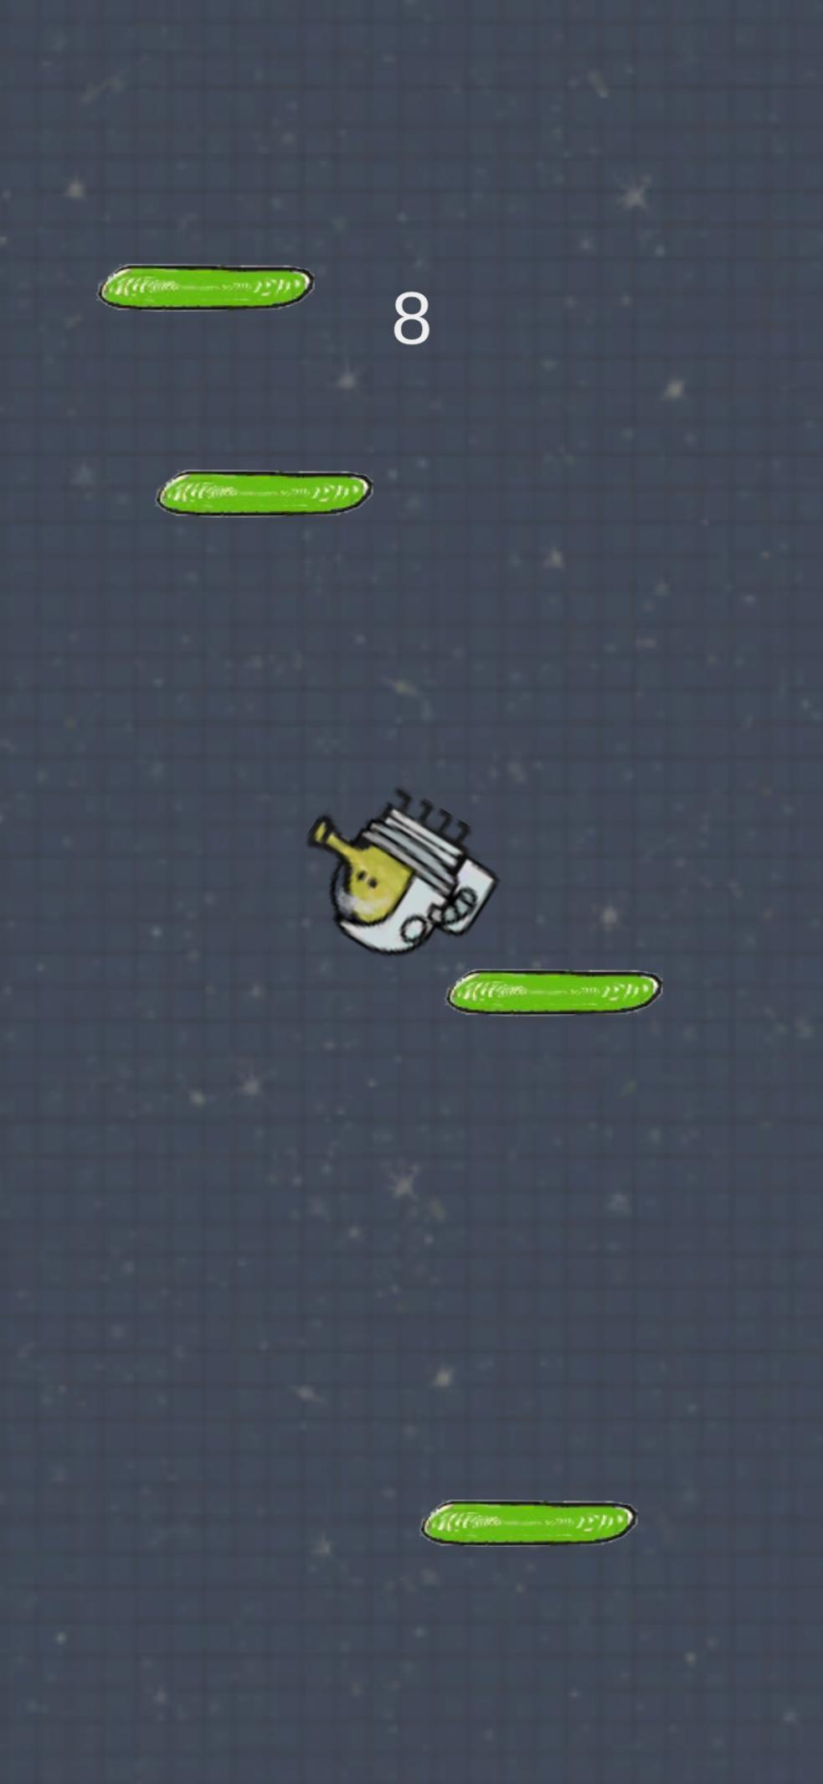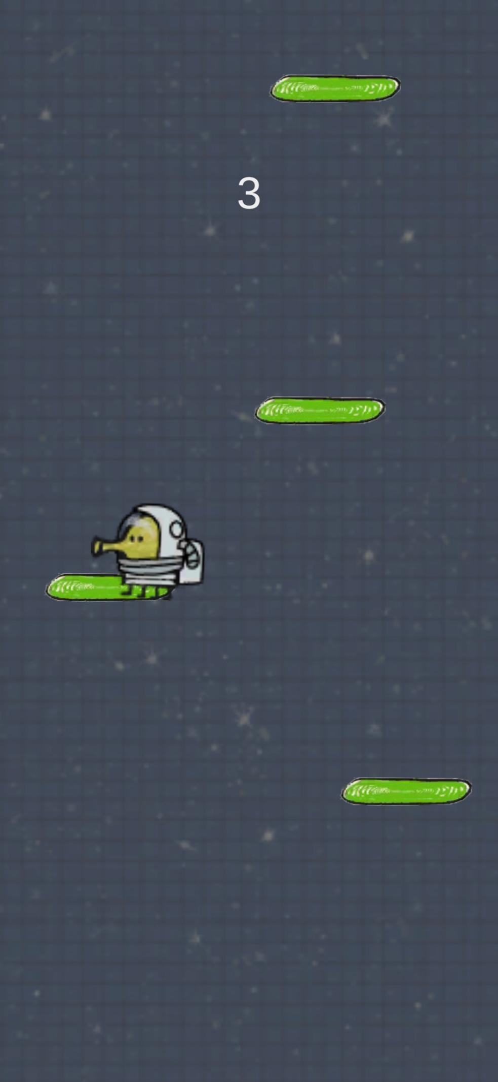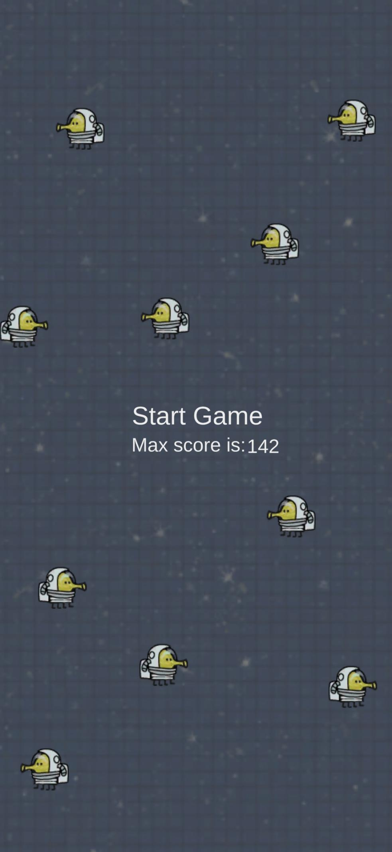

Исходный код:

Doodle.cs

using System.Collections;

using System.Collections.Generic;

using UnityEngine;

using UnityEngine.SceneManagement;

public class Doodle : MonoBehaviour

{

public static Doodle instance;

float horizontal;

public Rigidbody2D DoodleRigid;

void Start()

{

if (instance == null)

{

instance = this;

}

}

void FixedUpdate()

{

if (Application.platform == RuntimePlatform.Android)

{

horizontal = Input.acceleration.x;

}

if (Input.acceleration.x < 0)

{

gameObject.GetComponent<SpriteRenderer>().flipX = false;

}

if (Input.acceleration.x > 0)

{

gameObject.GetComponent<SpriteRenderer>().flipX = true;

}

var velocity = new Vector2(Input.acceleration.x * 10f, DoodleRigid.velocity.y);

DoodleRigid.velocity = velocity;

}

public Score ScoreScript;

public void OnCollisionEnter2D(Collision2D collision)

{

if (collision.collider.name == "DeadZone")

{

int lastScore = PlayerPrefs.GetInt("Score");

int curScore = ScoreScript.curScore;

if (curScore > lastScore)

{

PlayerPrefs.SetInt("Score", curScore);

}

SceneManager.LoadScene("Menu");

}

}

}

MainMenu.cs:

using System.Collections;

using System.Collections.Generic;

using UnityEngine;

using UnityEngine.SceneManagement;

using TMPro;

using System;

public class MainMenu : MonoBehaviour

{

[SerializeField] private TMP_Text maxScore;

public void Start()

{

int Score = PlayerPrefs.GetInt("Score");

maxScore.text = Score.ToString();

}

public void PlayGame()

{

SceneManager.LoadScene("Jumping");

}

}

Platform.cs:

using System.Collections;

using System.Collections.Generic;

using UnityEngine;

public class Platform : MonoBehaviour

{

public float forceJump;

public void OnCollisionEnter2D(Collision2D collision)

{

if (collision.relativeVelocity.y < 0)

{

Doodle.instance.DoodleRigid.velocity = Vector2.up * forceJump;

}

}

public void OnCollisionExit2D(Collision2D collision)

{

if (collision.collider.name == "DeadZone")

{

float RandX = Random.Range(-1.7f, 1.7f);

float RandY = Random.Range(transform.position.y + 20f, transform.position.y + 22f);

transform.position = new Vector3(RandX, RandY, 0);

}

}

}

Score.cs:

using System.Collections;

using System.Collections.Generic;

using UnityEngine;

using UnityEngine.UI;

using TMPro;

using System;

public class Score : MonoBehaviour

{

[SerializeField] private Transform player;

[SerializeField] private TMP_Text score;

public int curScore;

private int maxScore;

private void Update()

{

int pos = (int) Math.Floor(player.position.y);

maxScore = pos > maxScore ? pos : maxScore;

score.text = maxScore.ToString();

curScore = maxScore;

}

}

PlatformGenerate.cs:

using System.Collections;

using System.Collections.Generic;

using UnityEngine;

public class PlatformGenerate : MonoBehaviour

{

public GameObject platformPrefab;

void Start()

{

Vector3 SpawnerPosition = new Vector3();

for (int i = 0; i < 10; i++)

{

SpawnerPosition.x = Random.Range(-1.7f, 1.7f);

SpawnerPosition.y += Random.Range(1f, 3f);

Instantiate(platformPrefab, SpawnerPosition, Quaternion.identity);

}

}

}

CameraFollows.cs:

using System.Collections;

using System.Collections.Generic;

using UnityEngine;

public class CameraFollow : MonoBehaviour

{

public Transform doodlePos;

void Update()

{

if (doodlePos.position.y > transform.position.y)

{

transform.position = new Vector3(transform.position.x, doodlePos.position.y, transform.position.z);

}

}

}